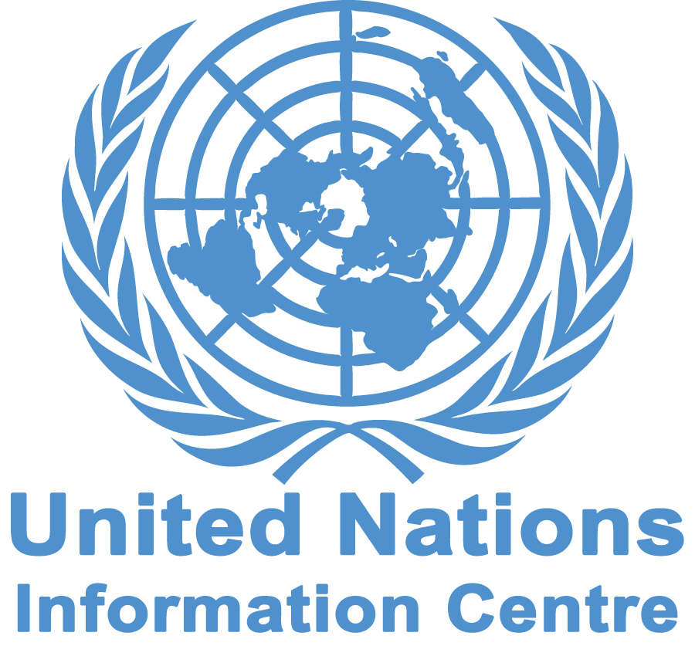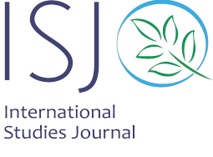

International Conference on
The Interactions of Transitional Justice and
International Humanitarian Law

International Studies Journal (ISJ) and United Nations Information Centre (UNIC) will hold an International Conference on the Interactions of Transitional Justice and International Humanitarian Law on the occasion of World Day of Social Justice in Tehran, Iran on 9th March 2017. The Conference will be held in cooperation with universities and research centers.

Conference Topics

Impacts of transitional justice on the expansion of IHL, evolution of transitional justice mechanisms, IHL and Peace building mechanisms of transitional justice, transitional justice and impunity, and IHL and transitional justice goals.

Certificate

ISJ and UNIC will award a certificate to all participants who successfully participate in the conference. The best articles which are presented in the conference could be published in ISJ

Terms and Conditions of Paper Submissions

- Title and abstract of the paper including goal, method, results, and achievements of research should be sent to info@isj.ir and internationalstudiesjournal@yahoo.com by 20th of February 2017.
- The paper can be in Persian, English, or French.
- The title, abstract, and the manuscript should not have been published or presented before.
- Payment of 200 Euros (150 Euros for Students) upon admission. Individuals who are interested to participate as the audience should pay the same fee. This fee covers registration, courses, booklet, ISJ quarterly magazines, coffees and lunch.

Deadline: 20th of February 2017

www.isj.ir

