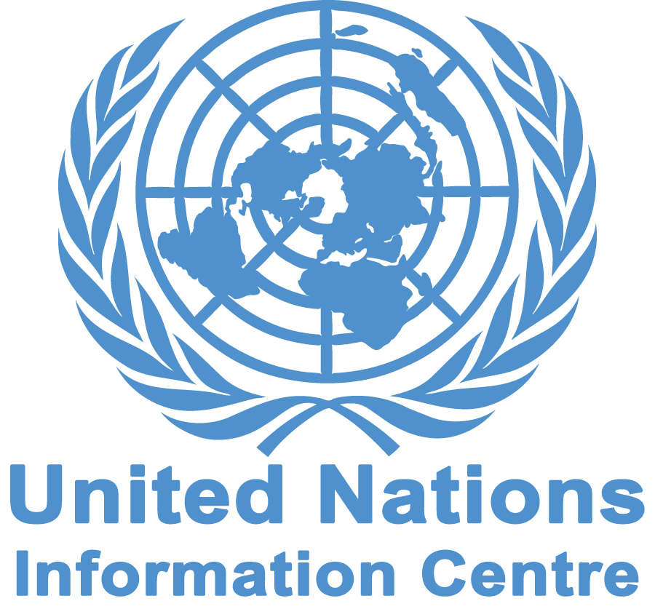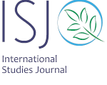

Workshop on the Occasion of the
International Day of Solidarity with the Palestinian People:
Human Rights and Intifada

International Studies Journal (ISJ) and United Nations Information Centre (UNIC) will hold an International Workshop on the occasion of the International Day of Solidarity with the Palestinian People, in Tehran, Iran on 8th December 2016.

Workshop Topics

This workshop will:
- Review the activities of UN Human Rights’ organs on Palestinian people’s rights
- Review the Intifada of Palestinian people and its relations with human rights;
- Review the Intifada methods regarding violence and their reflection on Human Rights.

Certificate

ISJ and UNIC will award a certificate to all participants who successfully fulfill the workshop assignments, research, and exercises. The best articles which are presented in the workshop could be published in ISJ.

Terms and conditions of participation

- An accredited degree in law, international relations or a relevant field of study
- Good command of English, Persian, or French
- A recent photograph of the participant
- A filled out application form which includes the applicant’s current address, telephone, email, and language skills (Persian, English, French);
- CV/Resume;
- Payment of 100 Euros (50 Euros for Students) upon admission. This fee covers registration, courses, booklet, ISJ quarterly magazines, and lunch.

Application & Contacts

In order to participate as the audience of this workshop and/or to present the abstract of your article, please send completed applications to: info@isjq.net and internationalstudiesjournal@yahoo.com

Visas

The ISJ will facilitate obtaining the entry visa.
Registration Deadline: 10 October 2016

